Tip 1

Sub Topic Sub Topic

Sub Topic Sub Topic

Sub Topic

Sub Topic

Sub Topic

Sub Topic

Sub Topic

Threat 4

Tips

Tip 3

# Threat

Threat 3

**Strength**

Threat 2

Threat 1

Tip 2

SWOT analysis

Sub Topic

Sub Topic

Strength 1

Sub Topic

Sub Topic Sub Topic

Opportunity 1

Strength 3

Strength 2

Sub Topic

Sub Topic

Sub Topic

Sub Topic Sub Topic Sub Topic

Sub Topic Sub Topic

Sub Topic

Sub Topic Sub Topic

Sub Topic Sub Topic Sub Topic Sub Topic

Summary

Opportunity 2

# Opportunity

Sub Topic Sub Topic

8/1 - 8/30 : 1.0 Month

Opportunity 3

Opportunity 4

Strength 4

Need to be improved

Gloria Team

Weakness 1

Sub Topic

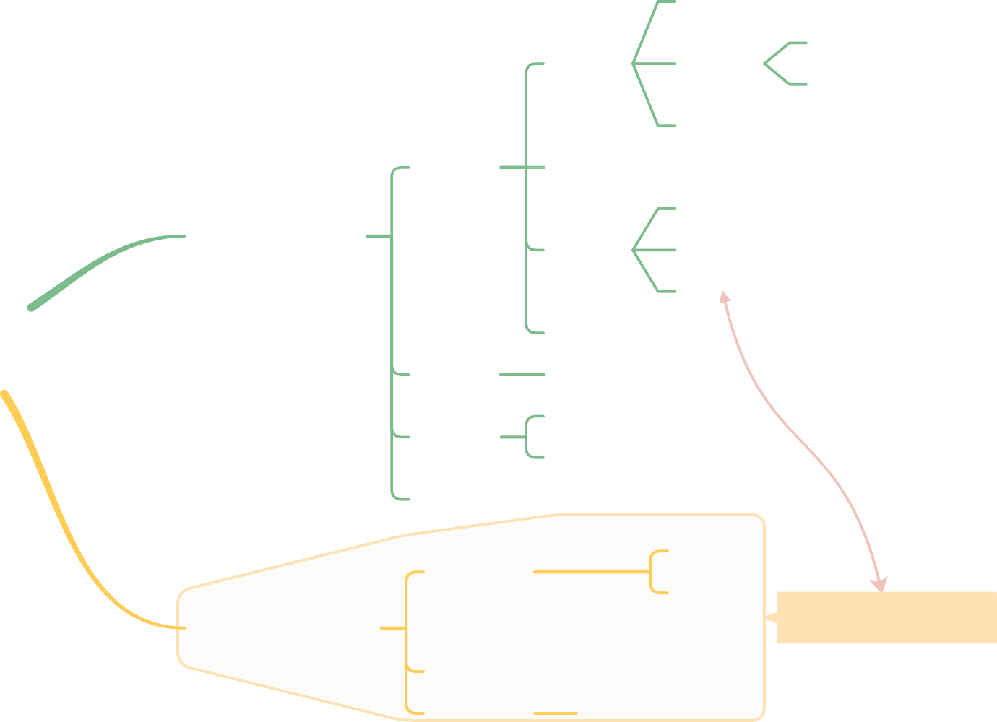

Weakness 2

**Weakness**

Sub Topic

Weakness 3